Vlad Predovic

CS 340

Due 11/08/2015

Assignment 4

[My website! --> http://web.engr.oregonstate.edu/~predoviv/CS340/hw2.php](http://web.engr.oregonstate.edu/~predoviv/CS340/hw2.php)

**Exercise 4.3** Write the following queries in relational algebra, tuple relational calculus, and domain relational calculus:

Suppliers (*sid:* integer, *sname:* string, *address:* string)

Parts (pid: integer, *pname:* string, *color:* string)

Catalog (*sid:* integer, *pid:* integer, *cost:* real)

1. Find the *names* of suppliers who supply some red part.

RA: πsname (π­­sid((πpidσ­­color=”red”Parts) ⋈Catalog) ⋈Suppliers)

2. Find the *sids* of suppliers who supply some red or green part.

RA: π­­sid(πpid(σ­­color=“red”V“green” Parts) ⋈Catalog)

3. Find the *sids* of suppliers who supply some red part or are at 221 Packer Ave.

RA: (π­­sid((πpidσ­­color=“red” Parts) ⋈Catalog))∪(π­­sid(σ­­address=“221 Packer Ave” Suppliers))

4. Find the *sids* of suppliers who supply some red part and some green part.

RA: p(R1, π­­sid((πpidσ­­color=“red” Parts) ⋈Catalog))

p(R2, π­­sid((πpidσ­­color=“green” Parts) ⋈Catalog)) R1 ∩ R2

5. Find the *sids* of suppliers who supply every part.

RA: (π­­sid,pidCatalog/π­­pidParts)

6. Find the *sids* of suppliers who supply every red part.

RA: (π­­sid,pidCatalog/π­­pidσ­­color=“red”Parts)

7. Find the *sids* of suppliers who supply every red or green part.

RA: (π­­sid,pidCatalog/π­­pidσ­­color=“red”V­­color=“green”Parts)

8. Find the *sids* of suppliers who supply every red part or supply every green part.

RA: (π­­sid,pidCatalog/π­­pidσ­­color=“red”Parts) ∪ (π­­sid,pidCatalog/π­­pidσ­­color=“green”Parts)

9. Find pairs of *sids* such that the supplier with the first *sid* charges more for some part than the supplier with the second *sid.*

RA: p(R1, Catalog) p(R2,Catalog)

π­­ R1.sid, R2.sid(σR1.pid=R2.pid^R1.cost>R2.cost^R1.sid≠R2.sid(R1×R2))

10. Find the *pids* of parts supplied by at least two different suppliers.

RA: p(R1, Catalog) p(R2,Catalog)

π­­ R1.pidσR1.pid=R2.pid^R1.sid≠R2.sid (R1×R2))

11. Find the *pids* of the most expensive parts supplied by suppliers named Yosemite Sham.

RA: P(R1, (π­­sidσ­­sname=”Yosemite Sham”Suppliers)⋈Catalog)

π­­pidσ­­color=“red”V­­color=“green”Parts)??????

12. Find the *pids* of parts supplied by every supplier at less than $200. (If any supplier either does not supply the part or charges more than $200 for it, the part is not selected.)

RA: (π­­sid,pidCatalog/π­­pidσ­­cost<200Catalog)

**Exercise 4.4** Consider the Supplier-Parts-Catalog schema from the previous question.

State what the following queries compute:

*1. πsname*(*πsid*((*σcolor*=*_red_Parts*) ⋈ (*σcost<*100*Catalog*)) ⋈*Suppliers*)

Find the Names of suppliers who sell red parts with a cost of less than 100.

2. *πsname*(*πsid*((*σcolor*=*_red_Parts*) ⋈ (*σcost<*100*Catalog*) ⋈*Suppliers*))

Nothing. Sid is projected alone, so sname cannot be projected from it.

3. (*πsname*((*σcolor*=*_red_Parts*) ⋈ (*σcost<*100*Catalog*) ⋈*Suppliers*)) *∩*

(*πsname*((*σcolor*=*_green_Parts*) ⋈ (*σcost<*100*Catalog*) ⋈*Suppliers*))

Find the Names of suppliers who sell red and green parts with a cost of less than 100.

4. (*πsid*((*σcolor*=*_red_Parts*) ⋈ (*σcost<*100*Catalog*) ⋈*Suppliers*)) *∩*

(*πsid*((*σcolor*=*_green_Parts*) ⋈ (*σcost<*100*Catalog*) ⋈*Suppliers*))

Find the Sid’s of suppliers who sell red and greenparts with a cost of less than 100.

5. *πsname*((*πsid,sname*((*σcolor*=*_red_Parts*) ⋈ (*σcost<*100*Catalog*) ⋈ *Suppliers*)) *∩*

(*πsid,sname*((*σcolor*=*_green_Parts*) ⋈ (*σcost<*100*Catalog*) ⋈*Suppliers*)))

Find the Names of suppliers who sell red and green parts with a cost of less than 100.

**Exercise 4.5**

Flights(fino: integer, *from:* string, *to:* string, *distance:*

integer, *depaTts:* time, *arrives:* time)

Aircraft( *aid:* integer, *aname:* string, *cruisingrange:* integer)

Certified( *eid:* integer, *aid:* integer)

Employees( *eid:* integer, *ename:* string, *salary:* integer)

1. Find the eids of pilots certified for some Boeing aircraft.

*πeid* ((*σAircraft*=“Boeing”*Aircraft*) ⋈ *Certified*)

2. Find the names of pilots certified for some Boeing aircraft.

*πeid* ((*σaname*=“Boeing”*Aircraft*) ⋈ *Certified*)

3. Find the aids of all aircraft that can be used on non-stop flights from Bonn to Madrid.

*πaid* (*σcrusingrange* ≥ distance ((*σfrom*=“Bonn”^to=”Madrid”*Flights*) × *Aircraft*)))

4. Identify the flights that can be piloted by every pilot whose salary is more than $100,000.

*p(R1, (πeid*(*σsalary*>”100,000” *Employees))* ⋈ *Certified)*

*πflno (σcrusingrange* ≥ distance (*Flights* × (*R1* ⋈ *Aircraft)))*

5. Find the names of pilots who can operate planes with a range greater than 3,000 miles

but are not certified on any Boeing aircraft.

*ρ*(*R*1*, πeid*(*σcruisingrange>*3000(*Aircraft* ⋈*Certified*)))

*πename*(*Employees* ⋈ (*R*1 *− πeid*(*σaname*=“*Boeing”*(*Aircraft* ⋈*Certified*))))

6. Find the eids of employees who make the highest salary.

*ρ*(*R*1*,Employees*) *ρ*(*R*2*,Employees*)

*ρ*(*R*3*, π R*2*.eid*( σ *R*1*.salary>R*2*.salary* (*R1* × *R2*)) ~*Select all where salary is greater, project the rest*

(*πeidR*1) *− R*3 ~*Only left with the greatest salaries after difference*

7. Find the eids of employees who make the second highest salary.

*ρ*(*R*1*,Employees*) *ρ*(*R*2*,Employees*)

*ρ*(*R*3*, π R*2*.eid*( σ *R*1*.salary>R*2*.salary* (*R1* × *R2*)) ~All entries except greatest(repeat process) (*R3*)

*ρ*(*R*4*,Employees*) *ρ*(*R*5*,Employees*)

*πeidR*3 *- π R*5*.eid*( σ *R*4*.salary>R*5*.salary* (*R4* × *R5*)

8. Find the eids of employees who are certified for the largest number of aircraft.

Cannot count in relational algebra. Therefore we cannot express this query.

9. Find the eids of employees who are certified for exactly three aircraft.

*ρ*(*R*1*,Certif ied*) *ρ*(*R*2*,Certif ied*)

*ρ*(*R*3*,Certif ied*) *ρ*(*R*4*,Certif ied*)

*ρ*(*R*5*, πeid*(*σ*(*R*1*.eid*=*R*2*.eid*=*R*3*.eid*)*∧*(*R*1*.aid*≠*R*2*.aid*≠*R*3*.aid*)(*R*1 *× R*2 *× R*3))) ~Appear 3+ times

*ρ*(*R*6*, πeid*(*σ*(*R*1*.eid*=*R*2*.eid*=*R*3*.eid*=*R*4*.eid*)*∧*(*R*1*.aid*≠*R*2*.aid*≠*R*3*.aid*≠*R*4*.aid*) ( *R*1 *× R*2 *× R*3 *× R*4))) ~Appear 4+ times

*R*5 *− R*6 ~Remove all that appear from that 3 times.

10. Find the total amount paid to employees as salaries.

Cannot count values so I do not think you can express this as relational algebra.

11. Is there a sequence of flights from Madison to Timbuktu? Each flight in the sequence is

required to depart from the city that is the destination of the previous flight; the first

flight must leave Madison, the last flight must reach Timbuktu, and there is no restriction

on the number of intermediate flights. Your query must determine whether a sequence

of flights from Madison to Timbuktu exists for any input Flights relation instance.

Cannot express in relational algebra because we cannot keep addings joins on the flight entity to search for existing flights indefinitely.

**Only use relational algebera and ignore relational calculus and domain calculus**.

# Database for a Spanish to English Services Company

**Vlad Predovic**

Fall 2015

2015

Database serving a Spanish to English services company

* Employees: EID, Name, PW, phone number, admin(binary)
* Clients: CID, Client Name, password, Email, phone number, address
* Work: WID, Date requested, Client Name, Date Started, Completion Date, Hrs. Worked
* Job: Job type, Date started, DID
* Service: Service type, Location
* Documentation(files): DID, Description, Media Type, CID, Date received

Introduction:

The database project will support a company that provides services for bridging the gap between English and Spanish speakers. This could be something as simple as translating a document or personal like communicating between a sick patient and their doctor and even developing learning material for non-English speakers. The company provides both jobs and services to its clients, and needs a way to keep track of this. Additionally, long-term clients will have accounts so they can automatically request additional items. The company needs a way to keep track of the many documents being worked on, be able to add and remove users, and keep track of hours worked on a job for all the employees.

Detailed Application Requirements:

The first implementation is a way for employees to see the work being done in table form. This will require some form of login/session-protected page with a table drawing joined values from the database. The table will portray jobs by creation date and have details like who is the ‘lead’ working the job, links to a file attached if applicable, and the status of the job/service to be completed. Additionally the owners of the company want to be able to adjust values themselves such as the time worked on the job, changing current parameters, and adding additional jobs. These user-oriented applications can be done through the implementation of form queries in php.

Another requirement that was decided upon with my sponsors was a way for clients to view the jobs they have requested, those they have completed, and be able to request more work. The issue here is that the company does not want to receive emails from regular clients each time a new job or service is needed. Regulars should have a way to submit work they want done and view their current history. Accounts for each long-term client will be added requiring that they be added to the database as a ‘client’ object. Once logged on a load query and some php code will bring up a table showing the client their history with a form option to add another request.

The company wants to be able to upload and keep track of information. This company will be dealing with documents a lot of the time due to the translating services that are provided. These need to be archived and connected to the rest of the database. The user will have a way to upload a file in relation to each job. Once this is complete, the document will automatically be related to a client, a work date, and a ‘lead’ employee through the implementation of the relational database. However, one of the limitations is the storage capacity of the servers. A work-around in consideration is using an existing system such as the Google Drive or Microsoft’s One Drive to upload files and then providing the URL link to these to be saved into the database. To users a file link would be displayed for the current job that would lead them to where the file that is being worked on is located.

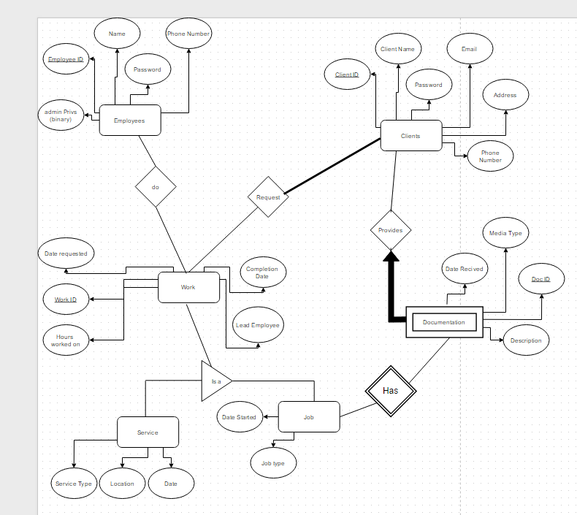

Table to Show Jobs in Work:

|  |  |  |  |  |  |
| --- | --- | --- | --- | --- | --- |
| Work ID | Date Started | Lead | Client | File | Work Status |
| 3235 | 5/4/2212 | Vlad Pred | BBB LC | www.zzz.com | Incomplete |
|  |  |  |  |  |  |

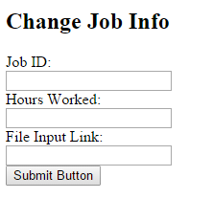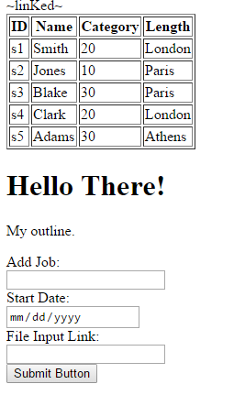

These are the couple of the forms Administrators and clients will be able to use to enter their information. On the left you can add a job along with a start date and a file link. This can be used by clients to enter jobs on their page. On the right an employee can enter values to alter their job info. The client has also requested the ability to query all requests/jobs by a certain employer and that these appear on a separate printable page.

Below is a rough sketch of what the Administration page might look like for an employee:

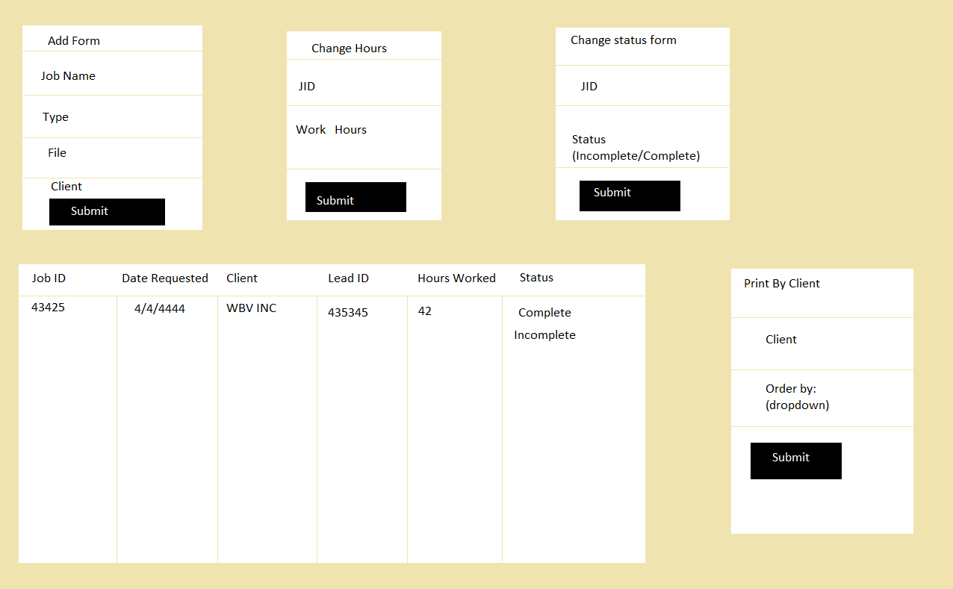

Tables, Entities, and Relations:

Employees (*EID: Integer*, Name: char (20), password: char (20), PhoneNumber: char (10), adminPrivs: Boolean)

Candidate Keys: EID, PhoneNumber

Work_On (*EID: integer*, *WID: integer*, HrsWorked: integer)

Candidate Keys: EID, WID

Foreign Keys: EID, WID

Work (*WID: Integer*, DateRequested: Date, CompletionDate: Date, LeadID: Integer (10), WorkType:

Char (6), CID: Integer)

Candidate Keys: WID

Foreign Keys: CID

Service (*WID: Integer*, ServiceType: Char (10), ServiceLocation: Char (50), ServiceDate: Date)

Candidate Keys: WID

Job (*WID: Integer,* DateStarted: Date, JobType: Char (10), DocID: Integer)

Candidate Keys: WID

Foreign Keys: DocID

Documentation (*DocID: Integer,* DateRecieved: Date, MediaType: Char (20), Description: Char 50))

Candidate Keys: DocID, Description

Clients (*CID: Integer*, ClientName: Char (25), Cpassword: Char (20), Email: Char (15), Address: Char (50), Phone: Char (10))

Candidate Keys: CID, ClientName, Email

1. CREATE TABLE EMPLOYEES (EID INTEGER, EmpName CHAR(20), Password CHAR(20), PhoneNumber CHAR(10), adminPrivs TINYINT, PRIMARY KEY(EID))
2. CREATE TABLE Clients (CID INTEGER, ClientName CHAR(25), Cpassword CHAR(20), Email CHAR(15), Address CHAR(50), Phone CHAR(10), PRIMARY KEY (CID))
3. CREATE TABLE Work (WID INTEGER, DateRequested DATE, CompletionDate DATE, LeadEID INTEGER (10), WorkType CHAR(6), CID INTEGER, PRIMARY KEY (WID), FOREIGN KEY (CID) REFERENCES Clients)
4. CREATE TABLE Work_On (EID INTEGER, WID INTEGER, HrsWorked INTEGER, PRIMARY KEY (EID, WID), FOREIGN KEY(EID) REFERENCES Employees, FOREIGN KEY(WID) REFERENCES Work)
5. CREATE TABLE Service (WID INTEGER, ServiceType CHAR(10), ServiceLocation CHAR(50), ServiceDate DATE, PRIMARY KEY (WID), FOREIGN KEY (WID) REFERENCES Work)
6. CREATE TABLE Documentation (DocID INTEGER, DateRecieved DATE, MediaType CHAR(20), Description CHAR(50), PRIMARY KEY (DocID))
7. CREATE TABLE Job (WID INTEGER, JobType CHAR(10), DateStarted DATE, PRIMARY KEY (WID), DocID INTEGER, FOREIGN KEY (WID) REFERENCES Work, FOREIGN KEY DocID REFERENCES Documentation)

Relational Algebra for user-driven questions

### What service dates are currently scheduled by Client ‘PtMedical’?

*πDateRequested*((*σClientName*=“PtMedical”*Client*) ⋈ *Service*) ~This is valid because service is a ‘Work’

Provide the ID of documentation available for jobs started in the last 30 days?

*πDID*((*σDateStarted*≤ “10/08/2015”*Jobs*) ⋈ *Documentation*)

What employees are currently leading a project?

*πEmpName*((*σLeadEID Work*) ⋈ *Employees*)

A listing of the amount of hours Sally Morris worked on jobs requested by PTMedical?

*p(R1, πWID*((*σClientName*=“PtMedical”*Client*) ⋈ *Work*)*)*

*p(R2, R1* ⋈ *Works_On* ⋈ (*σEmpName*=“Sally Morris”*Employees*)*)*

*πHrsWorkedR2*